This is why you would want Jay Gatsby as your commanding officer

- SHOP
- VA
- SURVIVAL
- Mighty 25
- TACTICAL
- CULTURE
- More
Top of Form
Bottom of Form
- Home
- MIGHTY SURVIVAL
- MIGHTY TRENDING
- MIGHTY TACTICAL
- MIGHTY CULTURE
- MIGHTY GAMING
- MIGHTY FIT
- MIGHTY MONEY
- MIGHTY HISTORY
- MIGHTY SPORTS
- MIGHTY MOVIES
- The MIGHTY FIT Plan
- MIGHTY MEMES
- PRESS
- MIGHTY HEROES
- MIGHTY STORIES
- ABOUT US
- Log in

popular

From Vietnam to Star Trek: 10 Questions with Tucker Smallwood
Joel Searls
Posted On September 09, 2021 01:20:00

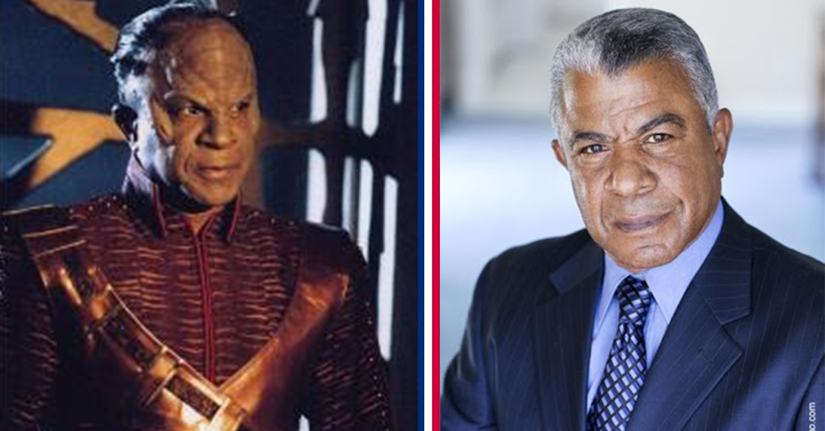
Tucker is a career actor with experience on stage, three times on Broadway, film and TV. He has roles in The Cotton Club, Contact, Traffic, The One and on TV shows such as “The X-Files,” “Space: Above and Beyond,” “Seinfeld,” “Friends,” “Star Trek: Voyager,” “Star Trek: Enterprise” and many more. He shares about his life growing up, time in the US Army in Vietnam, what it’s like to be wounded in combat and then his life in acting. He is a prominent veteran advocate and has been invited to speak at many different veteran events. His memoir, Return to Eden, has even more of his great life stories and wisdom. Sit back, relax and enjoy the ride.
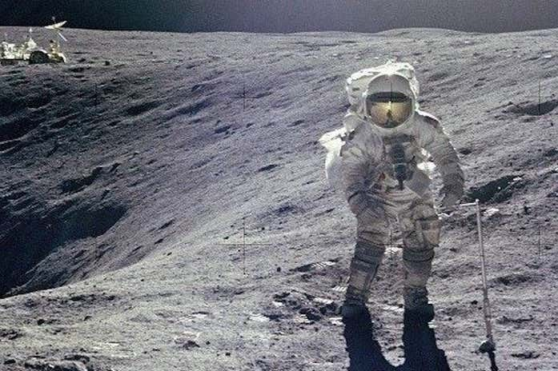
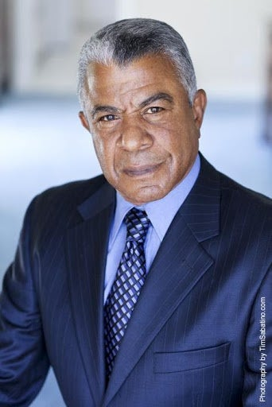
Photo credit IMDB.com
1. Can you share about your family and your life growing up?
Certainly. I was the second of four children and the first son. My father was a Lutheran minister who achieved his PhD in English, a professor at Howard University. In 1955, he was a Fulbright Professor at Anatolia College in Greece, where we lived for two years. I learned fluent Greek and studied the violin at the Odeon in Salonica. I spent two years of college in Munich, graduated from University of Maryland with a BA in Speech/TV Production and a minor in German. I then became the first director of color for WBAL in Baltimore and was drafted in July of ’67. My own memoir, Return to Eden, gives a detailed accounting of my early years. Additionally, there are numerous essays on my homepage.
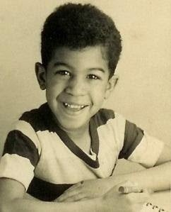
Tucker as a young child. Photo credit Tucker
An essay from Tucker titled “Lady Liberty:”
“I’m thinking tonite, even as I watch our traditions vanish into mist, that I have memories of classic imagery few if any of you will ever know. You see, I sailed from New York to Genoa and back…and to Southampton and back, in the days when most trips to Europe were done by sea rather than by air. I’ve since flown probably 15 or more times…but never with such resonance.
Each time going and coming home, we passed The Statue of Liberty. It was both a sign of departure and a sign that home was near. The first time as a child with my family, it was iconic. The second time as a college student, a fellow passenger bet me on which side we would pass. I took his bet and lost. He was a diplomat and a very decent dude and I enjoyed buying him a beer for our wager.
Point is, Lady Liberty has been a symbol of our unique freedoms during three centuries. For most of you, she is a photograph. But I’ll tell you what. When you’ve been at sea for days and days…and she appears in your view, you know you’re almost back home again.
I miss that simple, perhaps corny symbolism of coming home…to a place where freedom was something uncommon. I’d lived and traveled all over the world…and I’d learned and still remembered how very unique our republic is. It is damn sure worth fighting for.
I pray enough Americans value what I value and will vote in November to restore our singularity in the world.”
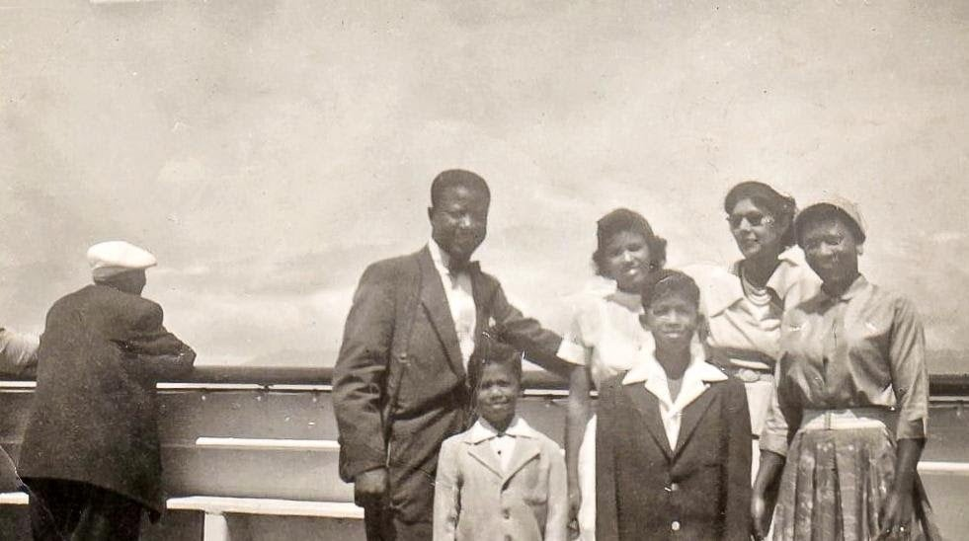
Tucker with his family. Photo credit Tucker.
2. What made you want to become a soldier and what was your experience like?
I was drafted. I had little patience for bullshit and some qualities that were useful. Assertiveness, intelligence, physical endurance, will. My test scores were largely off their charts, with particular language skills. I was offered OCS and accepted. I’d been a Cub and Boy Scout, enjoyed hiking and camping.
During Basic and AIT, I fell in love with the physical challenges. I wasn’t particularly large, but I was rated expert on 10 weapons and was very good with map and compass. The weapons are the M1, M14, M16, M-2, M-60, M1911, M40 (106mm) Recoilless Rifle, M67 (90mm) Recoilless Rifle, and then two more I can’t the last two. My personal weapons were an M2A2 carbine and an M3 “Grease Gun.” I also had an M14 with a starlight scope in addition to my M16. When you wanted to buttstroke someone the M14 was the best. During a Ranger exercise I went 10 days on nine hours of sleep. For a city kid, I enjoyed proving myself physically – particularly to myself.
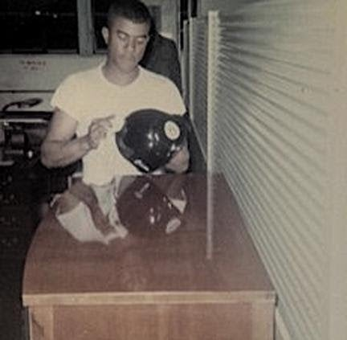
Tucker polishing his helmet. Photo credit Tucker.
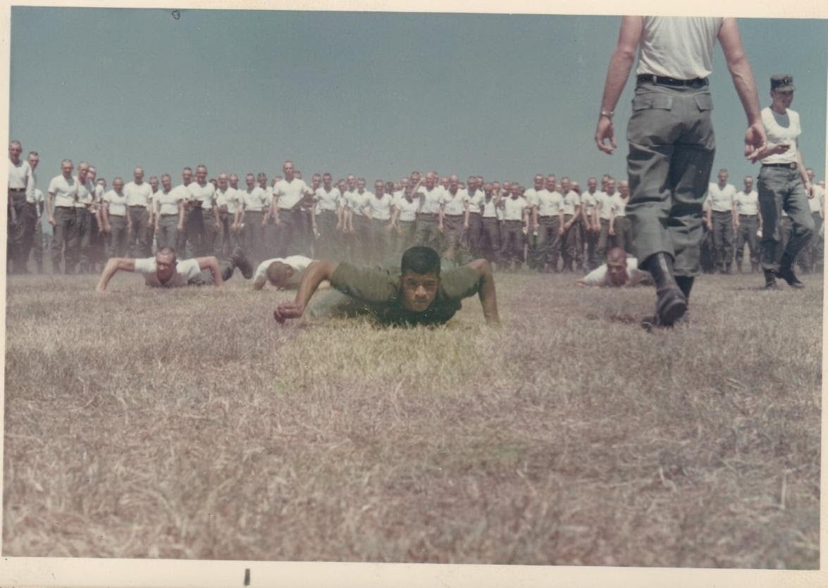
Tucker competing against his TAC officer candidates in the PT test. He won all PT tests against his candidates during his entire six month run as a TAC instructor.
I served as a Tactical Officer (TAC), training young Officer Candidates (OC’s). Regarding the Army PT test, I’d offered a weekend pass to any OC who could better my score. In six months, none did. I took great pride in setting the standard. I was not a nice guy; I was a very brutal TAC. The deal was to push men past their limits and see which ones could still function. I hated my own TACs yet I later understood why they were so brutal to me. My father had arranged a posting with Army Media, however I wanted to prove my mettle as a soldier. My graduation orders for Special Forces were pulled; the assignment of Tac Officers had the highest priority in Army training. I trained OCs for six months. The Army needed more junior officers because so many had become casualties in Vietnam.
When I got in country, my CO had been there for two weeks and then two weeks later I became CO. The night I arrived my CO took a small frag in the shoulder and then two weeks later took an AK-47 round in the buttock. There were five commanders in eight months, dead and wounded. I lasted five and half months myself which was a record. It was supposed to be a Major as a CO and a Captain as an XO. I made First Lieutenant a week after I joined the team, so I was a First Lieutenant as a CO.
My initial orders were to be a Liaison Officer to the ARVN airborne because of my Vietnamese language skills. Two weeks before I got there some ring knocker showed up and stole my slot either through a bribe, a buddy or some connection…so he took my slot. So, when I got there, they put me in this new concept, a mobile advising team. It was a five-man crew and I thought it sounded interesting. I loved my people, American and Vietnamese. I loved the work I did and I believed in it, although I did not believe in the war itself. I feel so fortunate that I got to teach my people how to fight and then teach THEM how to defend their village. I feel so fortunate despite my injuries.
When asked after my TAC officer tour I said I want Jump School, Ranger School, Special Warfare School and Vietnamese Language School and I don’t want to work with Americans. I had so many black and Latino NCO’s while a TAC told me what the deal was in Vietnam; they told me about the drugs, lack of discipline and grunts who didn’t want to fight the war. I didn’t want a frag rolled under my tent or a bullet in the back of my head. I am a hard charger; I just want to get the job done. I was going to do my job and wanted to work with people who weren’t going to screw around. I regret I did not get to do Ranger School, did all the other ones though. I am grateful for the experiences…but I wouldn’t do it again.
Afghanistan breaks my heart, to learn that men we were training might turn their weapons on their American advisors. I didn’t worry about that in Vietnam. It is difficult to bear.
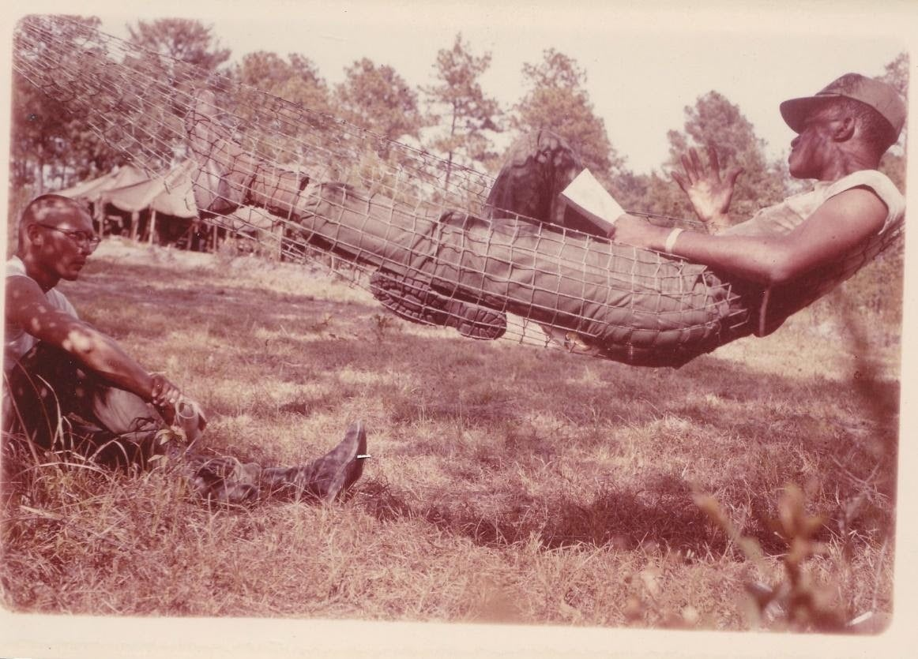
Tucker counseling one of his candidates, which was a big part of their training. Photo credit Tucker.
I wasn’t affected by PTSD until 10 years after coming home. Once a year I would a month or so before September 14th every year I would have night sweats and bad dreams. I would wake up shaking and in tears. My 51st anniversary of the day I was pronounced dead is Sept 14th. On that day for the first 15 years once it started occurring, I would be sobbing hopelessly and the next day I would be fine. It was like I shed my skin and was brand new, reborn. It is called “Anniversary Syndrome .” In recent years I have been doing very well. A year ago, on my 50th anniversary I broke down and had to leave an event with my friend and director Oz Scott.
I woke up with a headache but believe Sep 14th this year will be good overall. I have no complaints now or at 25 when they pronounced me dead. I have lived a full life even then.
We hide from our own shit sometimes where we see those faults or issues in others.
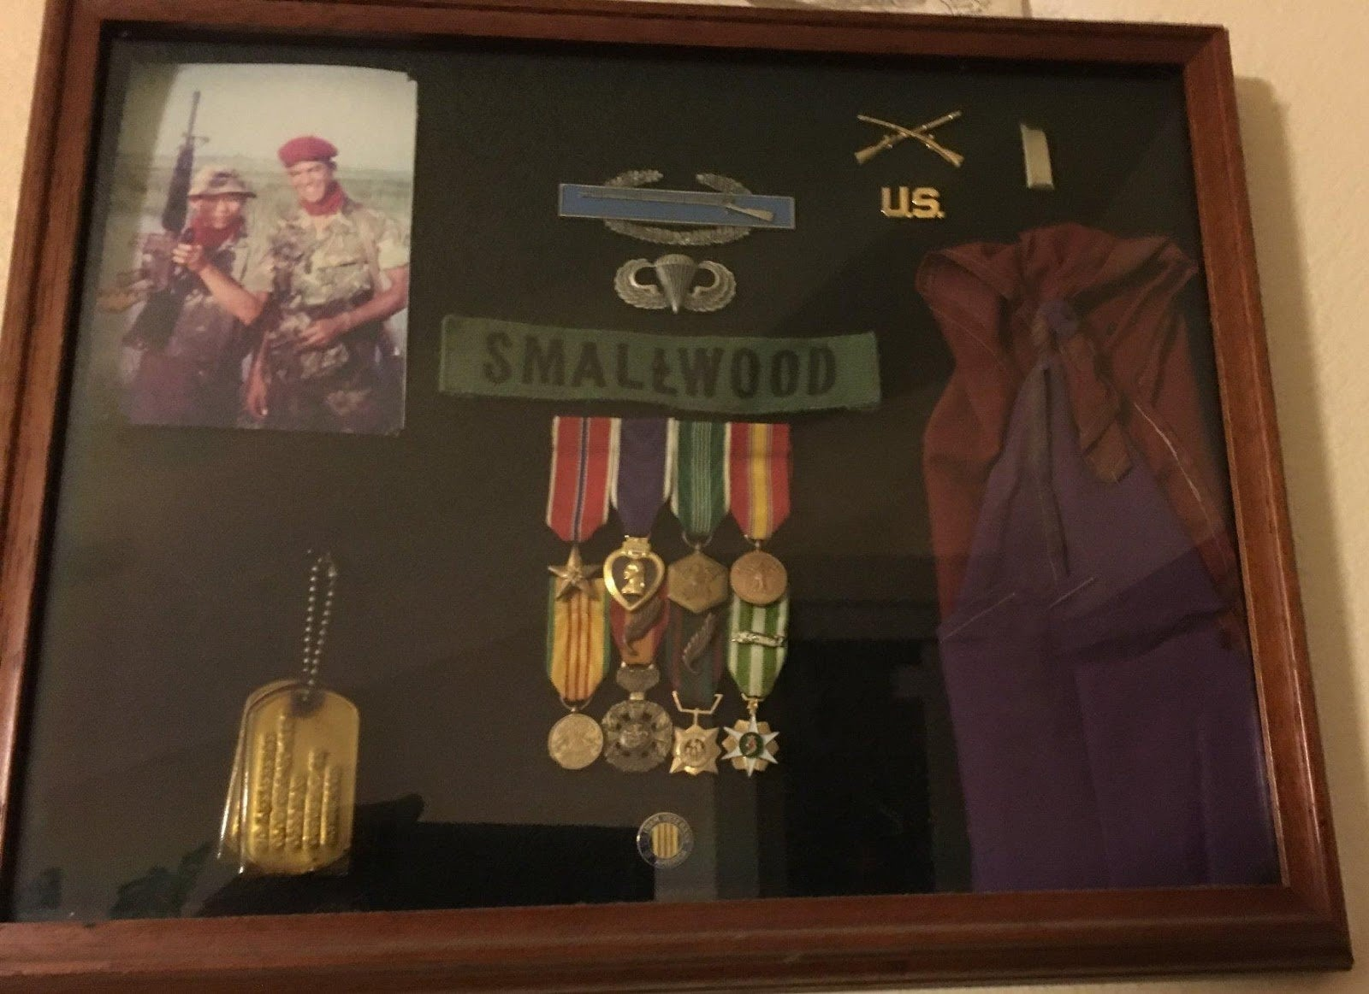
Tucker’s shadow box from his service in Vietnam. Photo credit Tucker.
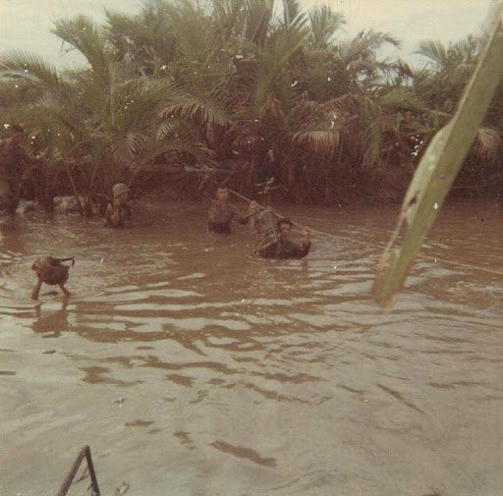
Tucker and his men conducting a river crossing in Vietnam. The essay for this picture is entitled BOOTLESS and they had their boots on while crossing. Photo credit Tucker.
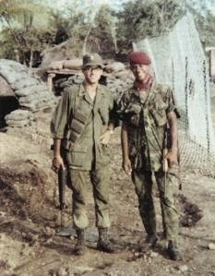
Tucker with his friend Jack Jolis in Vietnam. Photo Credit Tucker.
A chapter from Tucker’s book RETURN TO EDEN, the chapter is titled “FIRST NIGHT ,”
“Grady, our fearless leader, is searching frantically for his boots as ‘tings’ and ‘thuds’ of incoming AK rounds work their way along the PSP and sandbags of our bunker. For the next few weeks, I sleep in my boots. I leave him muttering curses, crawl out of our hooch and make my way around to our northern flank. I’m the newly arrived X.O. I’ve been here about five hours; I don’t even know everyone’s name yet…but my map is up to date.
They’d erected cyclone fencing to prematurely detonate incoming B-40 rockets – and a good thing, for I’m suddenly knocked to the ground by an explosion. Grady slipped in while I conferred with the Vietnamese commander and cried out, “Think I’m hit…” A flashlight exam reveals a minute frag wound to his upper arm. Without evident irony in his Oklahoma drawl, he pronounces himself fit to continue.
A few hours earlier, we’d spent the evening celebrating my arrival with more than a few Budweisers, chugging contests and numerous toasts. Our five-man advisory team was now up to full strength! After drawing straws for that night’s radio watch, I turned in, expecting a wake-up at 0200 hours.
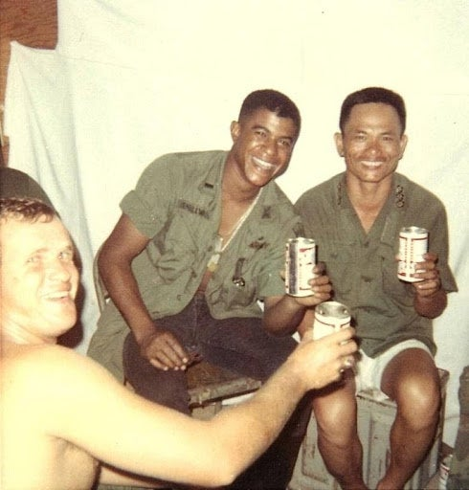
Sgt. Terry Brand, myself and Dai uy Minh. Photo credit Tucker.
I retreat to our southern flank to assess our defense and as I place a radio call for Tac air, Doc Garcia approaches me with a Hellmann’s jar full of green Dexedrine tablets. “Sir, you want your ups?” I look at him incredulously, surely, he’s kidding. Nope, apparently ‘greenies’ are SOP. I assure him I’ll be alert for the immediate future and he leaves to medicate the rest of my team. Then Sgt. Sparks hunkers down to ask, “Sir, would you like a beer?” Now, I know he’s kidding. Wrong again. I watch him low-crawl 20 feet to the cooler, ignoring the near misses, reach in for a six-pack of Bud and crawl back to pop one and offer it to me. This is his way of telling a young Lt. “Just another day at the office, sir. Rock steady and do what you’re trained to do.”
Charlie is bringing serious pee from three sides – RPG, small arms fire and the occasional mortar round. Looks like he’s got maybe 40-50 VC hoping to overrun this small CP. Before my beer is warm, I’m talking to the Phantom wing commander and negotiating the sequence of his weapons. First off, a canister of napalm from each F-4 illuminates our western flank. I imagine the smell of crispy critters mixed in with the singular scent of burning fuel oil. I’m also connected to the C-130 (Super Spooky) pilot, asking him to put out flares as the Phantoms begin to rake the perimeter with their Vulcan cannons. Spooky can orbit for hours, but the jets will soon break off to re-fuel and reload. And just in case, I’ve also requested a light fire team of Cobra gunships.
As I reflect that it’s good to be king, able to muster such formidable support within minutes, I suddenly notice that I’m “out of body,” a condition I’ve heard of but had never before experienced.
I’m floating perhaps 25 feet above my CP, looking down at myself as I/he switch radio frequencies to speak with different elements of support. This thought occurs to my doppelganger: “Damn, I’m good at this.” Hubris. My out-of-body persona is without any particular emotion but notices the similarity between directing a firefight and directing a live TV show (which I did for a living, before being drafted). I return to normal as suddenly as I’d left and would probably have enjoyed the experience much more had there not been work to do. Incoming has diminished considerably and understandably so, but the Cobras have arrived and deserve their turn, so I have them fly along the far canal bank, strafing with their miniguns. (We found a few parts and several blood trails the next morning, but Charlie religiously took his dead and wounded home, whenever possible.)
Perhaps an hour or so has passed since Grady began looking for his boots. I thank the Cobras and ask Spooky to hang for a bit while I check our casualties. Among the five Americans, we’ve got one wounded. Grady can wait for first light to go get his tetanus shot. But of my 47 Vietnamese soldiers, I’ve got two dead and five more critically wounded. They’re not likely to make it to daybreak, so I ask the Vietnamese com-mander, “Where’s the chopper pad?” There is none. “You’re sh*tting me, right? We have no chopper pad inside our wire?” Nope.
FUBAR. Cursing Grady under my breath, I ask the Dai uy for volunteers to carry the wounded outside our perimeter wire. “Too dangerous.” Probably right about that but we can’t just let them die without an effort. While I radio Bien Hoa for a dust-off, Sgts. Sparks and Brand organize litters and bearers…and under cover of the black delta night, we slip through our rows of concertina wire to the paddy dike behind our CP. Apart from the distant drone of Spooky in orbit, there is dead silence. I can still smell cordite and oily smoke and rice paddy… and myself. Sweat is streaming down my back, curiously cold on so warm a night. My handset crackles, “Rusty Nails, this is Dust-off, on your push, over.”
For the first time tonight, I am scared. Earlier I was too busy for errant thoughts, focused on each task – but now my imagination is running amok. I respond to the chopper, “Dust-off, this is Nails Six. Approach Echo-Whiskey, strobe marks green Lima Zulu.” (God, I hope it’s green!)
And the delta blackness is suddenly illuminated by the strobe light I key and raise into the night. It pulses an unbelievably intense pattern of light, evident for miles. And I wait for that first burst of fire, aimed just beneath the strobes flickering bulls-eye. Which never comes. Dust-off shuffles in, the red delta clay covering all in its wake and settles. We load on our wounded, thank Dust-off and make our way back thru the perimeter wire.
I’m now very tired – where is Doc when I need him? I begin rehearsing my speech to our commander Grady, questioning his decision not to have created a landing pad inside our wire. At first light, our soldiers are busily at work on just that task. And I promise God I will never do anything that stupid again. Yeah, right.”
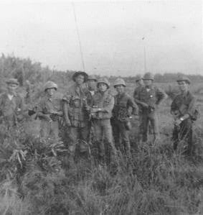
Tucker with his militia in Vietnam. Photo credit Tucker.
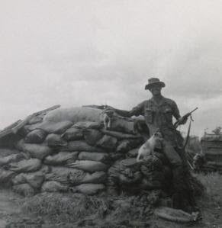
Tucker in Vietnam with his dog JoJo by his side. Photo credit Tucker.
3. What are you most proud of from your service in the Army?
Probably my conduct under fire, commanding men at war. (See Sunday, Bloody Sunday)
“Sunday, Bloody Sunday – September 14, 1969
I can remember kneeling, as I reached for my map case to check our position. We should be now within 300 meters of our objective. Then there was a thunderous, shattering explosion…followed by an eerie and absolute silence. “Have I gone deaf?” I wondered. No… for I could now hear an intermittent splattering sound, like someone pissing and stopping…and pissing again. I looked out to notice a thick, red stream, striking leaves some ten feet in front of me – which suddenly stopped, then repeated…and traced its source back to my throat.
My next three thoughts came faster than could be read or spoken. 1. I’m hit. 2. Pulsing means an artery is severed. 3. I’m going to die. If emotions had colors and form, imagine a massive wave – its color crimson, its essence: fear. “My Death Is at Hand .”
This wave surged across my consciousness, engulfed me absolutely, then washed away, immediately followed by the next wave, whose color was green, its essence: serenity. “All Will Be Well” (It is God’s peace, and a blessing. I can only hope I will find it again, when next I face my death.) For the past few months, I’d become convinced of my own invulnerability; I really believed I was somehow different, somehow protected from harm. Why? Because there’d been so many times I might have and perhaps should have been wounded – but was untouched – at least physically. This discovery of my own mortality was rude, abrupt, and absolute.
This peace remained with me, throughout. This peace is singular; it is a unique state of consciousness which often occurs in NDE’s. (Near Death Experiences.) It is one of five – Serenity, Out of Body, Instant Replay of Life, The Light… and an unremembered fifth. (Like naming the 7 Dwarfs, I always forget one.) I wore as a sweatband, my Vietnamese unit’s colors, a bandanna they’d awarded me after my first night with my team, one of our bloodiest encounters. I quickly tied it around my throat as tightly as I could bear and took stock of our situation. Men were dead and bleeding all around me, I could see no one untouched. Two lay in the water, blown off the hummock by the explosion, four lay scattered about, tending to themselves and each other. I carried the radio. I alone spoke English. If shock or unconsciousness took me, none of us would make it home. I quickly checked myself for other wounds, finding blood on my belly and left thigh, but knew they were minor, at least in comparison to my throat, and began keying the handset, hoping to raise an extraction or rescue force. I then realized I could not speak (turns out the frag that severed my right carotid artery had also severed the Vagus nerve, which controls the vocal cords; mine were now paralyzed.) All I knew then was that I could not speak … but discovered that I could whisper. And so, I began whispering into the handset, “Rusty Nails, Rusty Nails, this is Nails 6, over.” “Rusty Nails, this is Nails 6, over.”
No response. I was calling to my team base, praying someone there was monitoring the radio, someone who could then relay a request to the nearest available Dust Off and reaction force. I kept trying, over and over, as I watched these mercenaries, those still able, dealing with their injuries and setting up to repel any assault. Should I change frequencies, try VNAF channels? Would my whispered Vietnamese be understood and trusted, if I did reach someone? I chose to rely on my team not to leave com unattended for very long. As I continued to call, I considered what had happened.
Our mission was obviously compromised. Any VC not responsible for the explosion would soon be drawn to the site…but what was it? Probably not a mortar or artillery round, for I remembered no whistling sound of incoming, prior to the blast, and I saw no crater. Was it a grenade? The explosion seemed too large, (although I’d never before been at ground zero!) A booby trap or mine? And if so, set off by whom? By us? (I still have ghostly memories of having been told by SOMEONE that one of the mercenaries encountered a mine, which he was in the process of disarming, when it detonated.) Or were they still out there? What the hell were they waiting for? We were candy, lunch meat, toast, WIA’s about to become KIA’s…hardly the dangerous, canny team of experienced killers who’d set out some two hours ago on a mission that even today compels me to scratch my head and ask, “What in the world was I doing out there with them? THE F*** WAS I THINKING?”
Sgt. Sparks had said it so often, it’d become a mantra. “Sir, you keep lookin’ for it, you gonna find it.” Sparks was my senior NCO, 3 years in-country, he ‘knew the way’ and he’d surely lost enough young commanders to know the truth. (My team had already lost 5 commanders in 8 months – 2 KIA, 3 WIA.)
On this quiet Sunday morning, following a few weeks of boredom and no good contacts, a six-man PRU team (Provincial Reconnaissance Unit) appeared at my CP and asked to speak with me. They were all mercenaries. PRU’s were an arm of The Phoenix Program, a CIA funded operation, which conducted missions of assassination and counterterrorism; their mission – to neutralize the Viet Cong infrastructure. (I now know how totally compromised, illicit and f***** so many Phoenix operations ended up.)
At the time, I believed PRU’s to be among the most deadly and efficient operatives in a conflict that had become increasingly frustrating; we’d problems differentiating Viet Cong from farmer from sympathizer. Today’s mission: to capture or kill (whichever came first) a VC tax collector, operating centrally within my AO (Area of Operation), at a location relatively accessible… and recent intel suggested he’d be in the neighborhood this afternoon. They wanted my permission to go hunting on my turf.
I’d heard stories…stories about their occasional casual regard for certainty. These men were paid by the body. Their members included two Hoi Chans (ex-VC from the neighborhood, now on our payroll), two Saigon cowboys (sociopaths unfit for regular military service), a Nung (renowned tribal mercenaries), and a Cambodian (never did get his story). Knowing that they might well fail to find their quarry, believing that they might then choose to bag an innocent farmer, collect and present his head or ears for their bounty, I made a fateful decision. Over the months, my team had earned the trust and respect of the villagers we defended. For those insignificant few square kilometers in the Mekong Delta, Gia Dinh Province, Binh Chanh District, I and my team represented safety and justice. (It’s good to be King!) And I was unwilling to let these men betray that trust. Therefore, I must accompany them, insuring anyone they killed in my AO was someone who at least appeared to be deserving of killing. So, I was acting out of perceived responsibility, boredom…and an itch to operate with people I’d been told were among the best at what they did. Evidently, I still had something to prove, at least to myself. Pride goeth before a fall.
There was a brief window of opportunity to rethink my decision, for the Vietnamese Airborne was already at work, conducting a sweep not too distant from the target. Having operated with them in the past, I knew them to light up ANYTHING that moved in their universe. I’d learned to either be with them or in a different area code entirely, while they were out hunting. So, we sat on my deck and smoked for a bit, awaiting word their mission was complete and they’d been lifted out. Word came, soon enough, and after briefing my team and counterpart, the six PRU’s and I set off for the coordinates their intelligence sources had indicated this tax collector could be found. As usual, I left with a PRC-25 radio, M-16 and a basic combat load. This seemed nothing special…though I did change from my normal jungle cammies into a set of tiger fatigues, simply because they were all dressed in tiger – (and red beret, black skin and radio antenna notwithstanding, I generally tried not to draw unnecessary attention…unless we were waterskiing…)
It took us perhaps 2 hours to move from my base across the paddies, and into the thicker nipa palm, then jungle, then delta swamp of marsh, streams, and hummocks. After months of working with the ‘citizen soldiers’ that our conscripted troops essentially were, it was a pleasure to patrol with men who genuinely knew how to move efficiently, quietly, tactically towards their target. Though I can’t remember thinking so, I suspect some part of me was feeling rather self-congratulatory, for here I was, out on patrol with some serious operatives…and belonging, worthy to be among them. As I said, pride goeth before a fall. And then, nearing our objective, we pulled up from the cover of water and reeds, onto a small, dry hummock, to check our position. Without a word, we formed a small perimeter and I reached down for my map case. And the world exploded.
It’s been perhaps 25 minutes, still no response to my calls. My legs are pretty much numb from the thighs down, my arms growing heavy. My bleeding is slowed, but not stopped…how could it be? Others seem to be less vigilant, they too are growing weaker. And still we wait for the killing blow. I continue to whisper, changing my transmission. “Any station, any station, this is Rusty Nails 6. Mayday, Mayday…”
Suddenly a crackle in my handset…more static…and then a response.
“6, this is Nails, over”
“Nails, this is 6. Seven down, request immediate Dust Off near objective, please forward, over”
“6, Copy that, wait, out”
So now we had hope. No longer quite so alone. But still a long way from home free. As I waited, this thought suddenly struck me, “They are waiting for the Medivac chopper to come…to shoot it down, that’s why they haven’t finished us off!” Charlie lived to shoot down Dust Offs, and our pilots were so damn selfless and committed, they would come for us, danger be damned, LZ green OR LZ red, they would come down to get us, God bless them all. They were simply the bravest pilots that we had, bar none. Red Cross on the side of the chopper, Geneva Conventions attesting to their neutrality, Charlie lit them up on sight, Geneva Accords be damned, for he knew that our men fought with more courage, believing we’d be extracted and brought to care. And Charlie was so right. I’d called in numerous Dust Offs over the months, for both American and allied wounded and they always came – under fire, at night, in the rain, whatever. I admired the conduct of so many soldiers, acts both selfless and gallant that I witnessed during my command…but none so consistent and dependable as those men who flew the unarmed choppers that brought the wounded to safety. (I still resist making judgments on a people. After all, Viet Cong were the brothers, sons and fathers of South Vietnamese soldiers…but the fact is, during my command, I called in 20 or more medivac requests, all but one to extract Vietnamese casualties. VNAF pilots were on that same frequency, they had the same mission…but I never once got a VNAF Dust Off at night or under fire. Not one. Only American pilots would brave the danger to take my wounded from harms way.)
My handset crackled again, “6, this is Rusty Nails. Dust Off enroute, has your coordinates and freq, hang on, over.”
“Roger that, Nails. Be advised LZ not secure, request gunship backup, over”
“Copy that 6, wait, out”
And wait we did. It’s already been 45 minutes, perhaps a bit more. Still no sign of Charlie’s presence or intentions, but I remained suspicious. And waited… There is a sound that is to us like no other. It is unmistakable. It means,
“Help is on the way.” Even today, in-country vets still look up, instinctively, whenever we hear that characteristic ‘whop-whop-whop-whop’. It’s the sound of an approaching UH1B. A “Huey .” And I could hear it. Help was on the way.
“Nails 6, this is Dust-off, on your push, over.”
“Dust Off, this is 6. Be advised LZ may be hot, stand by for smoke, on your command, over.”
I beckoned a Hoi Chan to me, pulled a smoke grenade from my pack, gave him instructions, asked if he understood, and he nodded, yes.
“Nails, Dust Off. Pop smoke, over”
I mimed to my Hoi Chan to pull the smoke grenade pin, which he did and tossed it.
“Dust Off, smoke out, over”
“6, Dust Off, we see yellow smoke, over”
“Affirmative, Dust Off, yellow smoke, be alert, LZ is not secure”
“Roger that 6, we have back up, now on approach, over”
And they did have back up, by golly, for I could now hear the sound of several more choppers in the vicinity, among them, two gunships, rolling into orbit… and a slick bearing my District Senior Advisor, as it turned out. Events become rather jumbled in my memories now, as they were even then. I can remember watching the Medivac chopper touch down. And I was suddenly observing all this from above, from on high, perhaps 30 feet away.
For only the second time in my life, I was out of my body, (the first time, my first night with my team, under fire from three directions.) My dispassionate doppelganger noted my physical self below, now numb from the hips south. I continued to observe from two separate perspectives, as dead and wounded were placed on litters and loaded. I remember Maj. Arthur, my superior, the DSA, approaching me (only later wondering how the hell he managed to be part of this extraction). I remember extending my M-16, which he accepted, symbolic of surrendering to him my command of this operation and of my team. And I remember watching from on high, as medics lifted me onto a litter. Suddenly, I lay down there naked as the day I was born. Their scalpels had ripped through my jungle boots and tigers in seconds, as they searched for entry wounds. After an IV of plasma and a shot of morphine, I was blanketed and lifted onto the chopper. As they did, I watched my beret fall off, down into the mud…and then I returned to my body. (That’s a poignant memory, for I loved that beret…and I still wonder if an enemy soldier ever presented it to collect the standing 5000 piastre bounty for my death.)
That’s my last ‘out of body’ memory, from that day til now. Even as the morphine kicked in, I was still sufficiently aware to note the looks that passed between the medics. They were wonderfully professional and efficient, but their shared looks confirmed their skepticism about my survival. I had no opinion, pro or con.
I was and had been at peace for some time. Morphine simply meant ‘no more pain’. I felt like a Hershey Bar, molten on the Tan Son Nhut tarmac… yet my mind remained surprisingly clear. I was grateful I’d remained conscious long enough to get us out. I knew I’d done my best; that I’d acquitted myself honorably as a soldier…and that was enough. I was somehow complete – a perfection and peace I may never again achieve or experience. I accepted that this life had been interesting and was now ending…and quietly promised that if there was another life afterwards; well then, I’d try to do better, next time. The flight to Saigon’s 3rd Field Hospital took as long as it took…my life did not replay before my eyes. I remained conscious, though by now seriously drugged. I vaguely remember triage and more skeptical but caring eyes, a trip by gurney down a loooong tunnel, with bright lights overhead…then an operating room and still more lights…and at some point, all the lights went out.
I now know a great deal more…and in some ways, still nothing. I know that I finally surrendered on the operating table; that my heart finally stopped. I’m told that the surgeons surrendered too, all save Dr. Caesar Cardenas. For whatever reason, he refused to let me go and managed to make my heartbeat again. His surgery, reconnecting my carotid artery was brave (though clots soon formed.) But it was sufficient to keep me alive until some radical vascular work could be done back in The World, at Walter Reed. What I don’t know, and never will know, is what really happened to us out there that Sunday afternoon. There’ll be no biopsy on the chunk of metal that remains inside my neck, 1/4″ from my spinal cord, between C-4 and C-5. A quarter of an inch. That’s the margin between mute/bleeding – or paralyzed/soon to die; one more name on The Wall. I can never know how those six mercenaries fared, how many survived…but I have a strong sense that at this point, I’m the sole living witness to that encounter. Because I wasn’t supposed to be there, I was never debriefed by MACV or CIA or anyone else. Because I had no official connection to PRU’s and CIA; (since in their eyes “I wasn’t there”) none of this happened. I often wonder how this would have been written up, had we all died out there.
My actions, having chosen to be a part of this mission, cost me my command of MAT 36 and disadvantaged my team, until I could be replaced. That I regret. I needed no citations from the CIA or anyone else; what I did that afternoon was simply my job. To acknowledge my conduct would require they admit that I was there. “Xin loi.” (“F*** you, you’re welcome.”) This was not about gallantry or courage. I knew full well by then the standards I’d already accepted for such regard. What I did this day became my own ‘ultimate gut check’, a measure of my commitment to lives entrusted to me. My conduct this day was proof of a man’s will. There is no medical explanation for my having remained conscious and functional for so long, I should have died within minutes. God was there. The purpose given me by those who trained me to be an Infantry commander was there. The motto of the Infantry is “Follow Me.”
During my command, most of my people came under fire. Some were wounded and some died. This is fundamental to an Infantry Leader: “Anyone I take out – I will bring home.” I never violated that trust. And if I am remembered by my soldiers for that alone, that will do.
31 August, 2001″
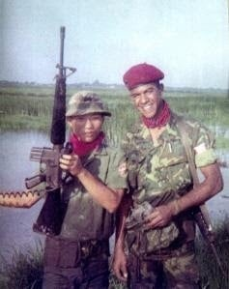
Tucker with T.U. Dai, his counterpart and brother in Vietnam. Photo credit Tucker.
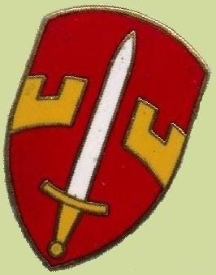
The MACV patch. Photo credit Tucker.
Tucker’s experience in the hospital and with his nurse are in the next essay,
“I’m sure I’m not alone in having a thing for nurses. Something about their firm calves in those white stockings and practical shoes and the way their starched blouses…well anyway, I’ve had my share of crushes on nurses. They’re just so damn perfect – comfortable with their bodies, great massages, no issues with scars… Now that I think about it, my second girlfriend was a nurse. (I named my puppy at Tan Nhut after her.)
In the TV series “China Beach ,” Dana Delany created an iconic character, Army Nurse Colleen McMurphy. She was tough, competent, caring, sexy, human…and her emotion was never self-indulgent, always earned. I very much admired her work in that show…and eventually I got to tell her so.
But I digress.
In the wards of 3rd Field Hospital in Saigon, Army officer nurses were stressed beyond belief. They contended daily with an abundance of young broken bodies and shattered spirits. Some of their patients were not going to get any older; some wished for an end to their pain. These women had to find that nurse’s balance between caring for these men yet maintaining some emotional distance. Each found her own formula, but many of them came home as haunted as the men for whom they’d cared.
I have a picture of my nurse from Vietnam but can’t remember her name. I searched in vain for years, wanting to thank her, to tell her how much she’d meant to me, how much they’d all meant to us at that fragile time in our lives.
After about a week at 3rd Field, I was coming along. I’d learned to shower with plastic wrapped around my thigh, to prevent my metal sutures from rusting. I was still losing weight, (still fed intravenously) and still grateful to be around. My veins were all pretty tired and one weary nurse was having a tough time getting my IV properly installed. She failed time after time and I was losing patience, that shit really hurt! A spry, elderly bird colonel appeared beside her, sussed the situation and without a word, relieved her of the needle. In one deft move, she inserted that IV into my challenged veins with certainty, smiled and wheeled away. Ahhhhh. I exchanged a grateful smile with the younger nurse. We were both relieved. She’d been doing her best, and I’d never doubted that but still, it’s nice to find an old pro when you need one.
At the end of my second week, I overheard my doctors debating the removal of my trach. “He’s doing well, he’s fought off infection, maybe we can get him started on soft foods…” “Well, let’s give it a bit more time…” Later that night, I lay there, feeling a bit sorry for myself. There may have been a few tears in my ears, I’m not saying. I’d had nothing to eat or drink for fourteen days. Into the darkness of the ward appeared my very favorite nurse, an anticipatory smile on her face, and holding a small Dixie cup of vanilla ice cream.
She came to the side of my bed, saw that I was awake and lifted a small spoonful of heaven to my lips. That remains the single most intense experience of flavor I’ve ever known. Two more spoonfuls, each sweeter than the last, then she put her finger to her lips to remind me this was our secret and slipped out of the ward. I lay there in the dark, smiling with the memory of our tryst, eternally grateful for that kindness. I hope she knows how much I loved her in that moment.
Dear Tucker,
After reading your chapter about me, I am so back in Vietnam. What an honor to hear from you after so many years. To have a chance to tell you how much I loved you and all the brave young men I took care of is one of my greatest wishes.
You all meant so much to me! I am so blessed to have taken care of such brave young men. I have felt truly honored since that experience. My caring touch, my smile, my compassion, my passion as a nurse to care for your wounds and care for your spirit was truly my mission.
In my 38 years as a nurse, that one year as a nurse in Nam pretty much shaped me in my nursing and my life. I was forever changed. Some good and some not so good. I too suffer from PTSD. I get counseling from time to time. But I have managed to raise two great kids and have been married for 36 years.
Please believe me, it was such an honor to care for you and to help you heal. I am haunted each day about the hundreds of young men I cared for wondering what happened to them. To know you made it makes me feels so warm in my heart. You all are forever imprinted in my heart. Please keep in touch and hopefully we can meet so day soon and I can give you a big hug.
Love Ellen
Your McMurphy!”
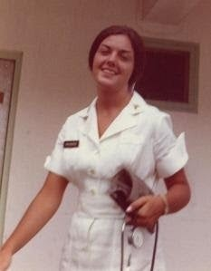
Tucker’s nurse Ellen in Vietnam. Photo credit Tucker.
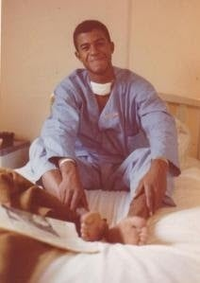
Tucker in the hospital in Vietnam recovering from his wounds. Photo credit Tucker.
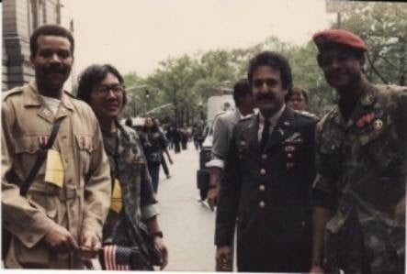
Tucker with his friends Michael and Bob at the first American Vietnam Veterans Parade. Photo credit Tucker.
Tucker shares a few neat things that he loves Austin Healey cars and his first car was a GTO he bought off Victory Drive at a car dealership outside of Fort Benning while training for Vietnam. He shares about how fast the car was and how he loved cornering on sharp turns in his Austin Healey.
4. What values have you carried over from the Army into Hollywood?
Punctuality. Dependability. Patience. Moral courage. Professionalism.
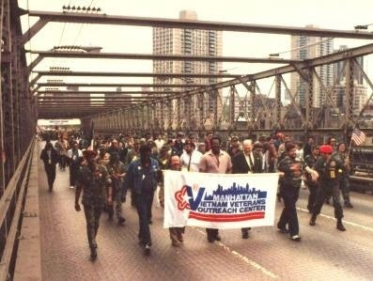
Tucker marching in NYC for the first Vietnam Veterans Parade. Photo credit Tucker.
5. What project did you most enjoy doing while working in Hollywood?
Several of the projects below.
Space: Above Beyond will always be my proudest series work. My character was myself, the same values, 25 years after Vietnam. My favorite film experience would be The Cotton Club, particularly the recent re-edit: The Cotton Club Encore. Closely followed by CONTACT, my first major film lead.
I’ve had a very Zelig-like career. I’ve known Chris Walken since the mid-70’s. Morgan Freeman was in my very first play in 1972. Denzel Washington was my understudy in ’78…and Sam Jackson was in that same production. I was in Greg Hines very first play and we remained close friends until his death.
In my first I play I got to act with Morgan Freeman, where I wanted his role, but he got it. The public theater in NY has so many theaters where I got to watch so many great actors and actresses of the 70s and 80s perform. I got to see Christopher Walken on stage, which was wonderful. In the late 1980’s at a benefit for theater in NY, I was able to work on stage with Christopher and Matthew Broderick in a scene from “The Basic Training of Pavlo Hummel .” I love watching young comedians imitate Chris and then Chris do Chris where he has such a great sense of humor about himself. Deer Hunter is my favorite role of Chris’s.
Tucker’s essay “Familiarity Breeds Contempt ,”
“During the mid-70’s, I lived in New York City and was fortunate enough to appear on all three networks each week. I starred with JoBeth Williams in Jabberwocky, an ABC children’s show; I was ADA Frank Evans on NBC’s soap opera Somerset and the Emmy-nominated host of the CBS news magazine, Channel 2: The People. Combined with dozens of national commercials, I became accustomed to being recognized and greeted on the streets of New York City on a daily basis.
This was hardly movie star, rock star, sports star fame…it was comfortable, rarely threatening, a little like living in the neighborhood in which you’d grown up and being known by just about everyone.
People of color in particular always seemed to know my face and the characters I’d played; there were relatively few Black actors appearing on any regular basis in TV back then. It was pleasant; I thought little of it and went on with my life.
During the 80’s, although I became less successful on-camera, I remained in the daily lives of most Americans as the voice of more than a thousand radio and TV commercials. I still did the occasional play or film, there were a few successes, like THE COTTON CLUB and PRESUMED INNOCENT; but I was beginning to unravel, emotionally.
A subtle and perverse condition called Survivor Guilt encouraged thoughts of ending my life. My subtext had become the sense that I didn’t deserve to be happy, to be successful, to be alive. I struggled in denial for several years, depressed and self-destructive. Eventually people who cared about me persuaded me to ask for help and I was blessed once again.
I was put in touch with Dr. Victor DeFazio, a therapist who’d served in Vietnam before completing his studies in psychology. He accepted only veterans and policemen as patients and for several years before the fall of the Soviet Union, had worked with Russian psychologists to develop therapies for their Afghanzi. These Russian soldiers, returning from an unpopular and unsuccessful guerilla war in Afghanistan, had much in common with troubled Vietnam veterans.
With his help, I began to think more clearly and recovered my appreciation for the blessing of my life. I moved to California in 1991 and began to work more and more in prime time – in dramas, sit-coms, and most successfully, in the genre of science fiction.
I’d never been a very good ‘type’. In the eyes of casting agents, I seemed atypical of contemporary Black men in American life. But they decided perhaps someone like me might exist in the future – and my career was reborn.
Over a six year period, I appeared in some of the highest profile sci-fi shows on television, including The X-Files, Star Trek: Voyager, Star Trek: Enterprise, Millennium, Babylon 5, and Space: Above and Beyond, as well as in films like CONTACT and DEEP IMPACT. And a curious synergy between the growing popularity of the Internet; the proliferation of cable and a body of work that now spanned almost thirty years combined to make me, once again, familiar.
Not famous, not even remotely – but somehow, familiar. People I encountered ‘knew’ me, though many had no idea why. Some assumed we worked out at the same gym, or lived in the same neighborhood, or had gone to school together. Others could recite my projects chapter and verse, remembering roles even I’d long forgotten.
As always, it was the working people – bus drivers, stewardesses, baggage handlers, cabbies, policemen that seemed to notice my presence and their greeting was always a positive experience. They were genuinely tickled to encounter me and say hello. It really didn’t matter how far I traveled – India, Romania, Germany, Australia, England, Peru, Vietnam – thanks to the worldwide distribution of our media, I was suddenly recognizable to citizens all over the world.
So, my destiny is to be ‘familiar’. There are worse things; I can live with that. In this age of media addiction, I’ve had my share of fan mail and photo requests, but I’ll tell you what still gives me pause. I recently typed my name into the search engine Google. It came back with more than 261,000 references to web sites and pages discussing my work. Imagine that.
My father, Dr. Osborn T. Smallwood was a Lutheran minister, university English professor, Fulbright scholar, diplomat and civic leader. He is someone I admire and respect as much as anyone on this earth. I typed his name into that same search engine and found two references – a 1999 resolution by Ohio State University honoring his memory and a Stars Stripes article, the photo from which appears at the beginning of this essay.
Whenever I am tempted to feel remotely self-important, I am mindful of an absurd inequity in our culture – there is a lack of regard for genuine accomplishment and an obscene obsession with celebrity.
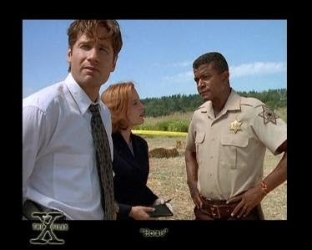
David Duchovny, Gillian Anderson and Tucker in “The X-Files .” Photo credit Tucker.
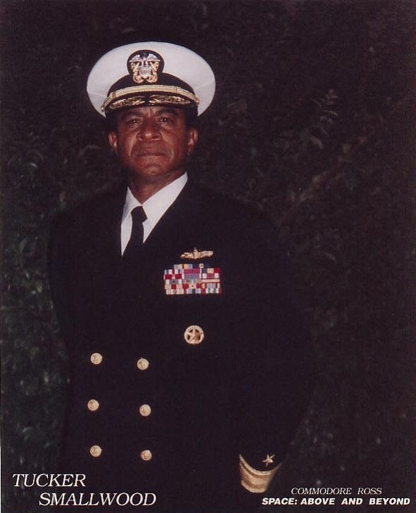
Tucker in “Space: Above Beyond .” Photo credit Tucker.
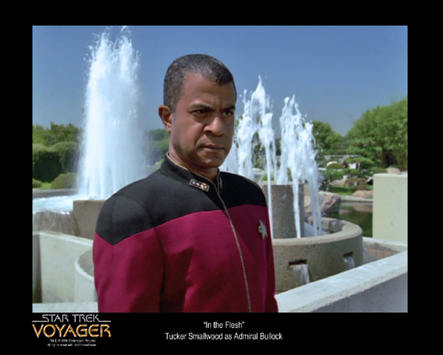
Tucker in “Star Trek: Voyager .” Photo credit Tucker.
6. What was it like working on such projects as The Cotton Club, Presumed Innocent, The X-Files, Seinfeld, Contact, Deep Impact, Star Trek: Enterprise, Curb Your Enthusiasm and your own work of “Return to Eden”?
Working “Seinfeld” was great where everyone was so professional. All of the actors on the show knew just how much humor to add to a scene, where they could make the scene funny as hell.
In “Space: Above Beyond ,” I was able to mentor younger actors. The role was me basically 25 years after Vietnam. The actors confided in me as well. There was a lot of trust and unique. The writers Jim Wong and Glen Morgan wrote the character for me and then wrote characters for me in “X-Files” and “Millennium .” They are like artistic godfathers to me; they are very generous and kind to me. I will always cherish working with them.
I would love the opportunity to work with Clint Eastwood sometime. Never had the chance, but would love to work with him.
Tucker’s essay about his career during the 1970s “Finding a Way ,”
FINDING A WAY
“I’ve really had four acting careers, in retrospect. I was rarely if ever a “good type .” Media perceptions and depictions of Black Americans has evolved markedly during my professional life. It began in 1972. I was then an acting student, under the G.I.Bill and my earnings as a waiter at The Goose and Gherkin. This pub-restaurant existed between two very high-end New York restaurants: Lutece…and The Leopard, less well known but no less elegant. I don’t recall ever having entered either.
But my personality was well suited to be a NY waiter and I enjoyed bantering with my customers. The Goose was on E 50th St, the customers from Madison Ave and the neighborhood. One night I served a table of perhaps eight people. They were animated, enjoying each other’s company. One spoke to me as I cleared their dinner plates. “You’re a hell of a waiter!”
I’d never doubted the largesse to be left to me, my tip…but I took a shot. “I’m even a better actor.” He smiled and said, “I’ll bet you are.” The next day I read for “an under five” character for his soap opera…and was cast.
As we shot, just before I entered, the stage manager told me to respond and say, “That’s correct.” I did…and it meant I got paid rather more money. The next day they read me for a continuing role. Frank Evans. Homicide cop. And then they offered me the role. It meant I would make 0 each day I worked. But there was a problem. Sandy Meisner and The Neighborhood Playhouse didn’t allow their students to accept professional jobs. Viewed it as a distraction, a form of corruption.
So, it came to pass that in a two-week period, I left my studies at The Playhouse…to begin my career. And then, so did Jeff Goldblum…and for a play. Two Gentlemen of Verona. He was 17, a talented actor, singer, musician…It was absurd. It’s 1971. I’m 27, a surviving Vietnam veteran…who decided to become an actor while he recovered at Walter Reed. Jeff – and pretty much everyone I’d recently met had known each wanted to be an actor, a performer, much of their lives.
I began modestly but gained traction. I got an Equity play at the Public Theater. That’s when I first met Morgan. And my theater work earned me a legitimate agent. Marge Fields. And her assistant was MaryJo Slater. I began to book national commercials. I went to Boston with JoBeth Williams. We shot 55 episodes of JABBERWOCKY. ABC later syndicated them nationally. And then I was cast as the host of CBS Channel Two: The People. It was an early news magazine. Apparently, I was good at this. Second season, the producer, writer, director, editor fired me. We were a good team. I was the host and he did everything else! The next week I was nominated for an Emmy for my work on his show. My first Austin-Healey Mk III was purchased from the resulting AFTRA-induced settlement.
More plays and readings. More projects. More commercials. Then came the meeting with Stanley Sobel for a role on SEARCH FOR TOMORROW. A soap opera that had been around since Christ was a corporal. They had never before had an actor of color under contract. Not since 1951. I read a few pages of the scene…and Stanley stopped me. “I don’t need to hear anymore.” He showed me a yellow legal pad with the entire first page filled from top to bottom with appointments. “I don’t want to see anyone else. I want you to do this role.”
It was my turn to sit back. With utter sincerity, I told him, “Stanley, I came today just to meet you, so that you could know me. I can’t take this role. I’ve just committed to Joe Papp, to be a part of the Black-Hispanic Repertory Company. We’re going to perform Coriolanus and Julius Caesar in repertory.”
I remember that Stanley then sat back too. And he said something that was to me seemingly cryptic. “OK. You let me concern myself with that.” And I left. (I should mention that Stanley Sobel, before having joined CBS was Joe Papp’s casting director. As had been Eileen Knight and Mary Colquhoun and Rosemary Tishler, among others.)
So, Stanley and Joe decided to make it possible to do both. The next seven months were among the most challenging months of my life. I handled my business. I did the soap in the morning, caught a character class with Stella in the afternoon and did Shakespeare at The Public Theater at night. I did that from late autumn well into the spring. And THEN, they invited me to participate in Shakespeare In the Park that summer. And I said “No. Thank you…but no.”
I was so burned out. I think Denzel assumed my characters that summer. 😉 With all of the internal drama that accompanied our repertory adventure, I’d been dealing with an entirely different issue on the soap. PG wanted to sign me to a long-term deal. Years. I was resistant. I enjoyed my work, the writing, my fellow stars. Yet I was frustrated by the seeming unwillingness to create my own reality. I existed as Executive Assistant to a mogul. Think Ted Turner, but younger. For a while Lisa and Travis ruled daytime as the resident Princess and Prince. And I was his…Hand. Yeah, that you can understand. 😉
So, when it came time sign a contract, I refused to sign for more than six months. They wanted two years. I had “go to hell” money from commercials. I really didn’t consider the money they offered. I knew I didn’t enjoy existing without my own life on this show. After six months, nothing meaningful changed…and I simply left.”
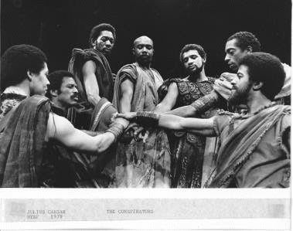
In the production JULIUS CAESAR. Photo credit Tucker.
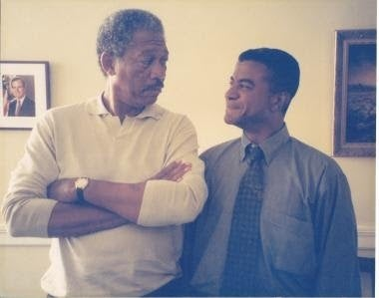
Tucker with Morgan Freeman on Deep Impact. Photo credit Tucker.
Tucker’s essay on working with Gregory Hines:
“It’s not listed among Greg’s theater credits, THE LAST MINSTREL SHOW, which starred Della Reese and was slated for Broadway. But after out of town runs in Delaware and Philadelphia, we never arrived at our slated opening at the Helen Hayes Theater. (I still have that NY Times full page ad announcing our arrival) So it goes.
Our producers included Colleen Dewhurst and they simply ran out of money, couldn’t get the sets out of Philly. The music and dancing were compelling, and the book engaged the use of blackface in a time of social change in America. My character, Jimmy “Tuskeegee” White questioned the morality of “corking up” to perform our music, believing it to be demeaning to people of color. In the second act, he confronts Black Sally (Della Reese) with his concerns and choses to quit the production.
Greg had been a performer for all of his life…but this was his first dramatic character role. He was brilliant dancer and singer; his instincts were solid, but he’d had little prior training as an actor. (I’ve had the singular pleasure of having tap danced with Gregory Hines and Jeffrey Thompson on a Broadway stage!) 😉 During the run he approached me one afternoon and asked, “Tucker, every night you play that scene…and you break down every night, often on the same word. How do you do that?” I described to him my training with Meisner and with Stella, spoke of “a preparation” and the actors work of creating a character’s history, back story and how that would inform his work, once in performance.
I don’t remember if Greg ever told me who he chose to study with…but I do remember a call late one nite. I was then living in a Tribeca loft. My phone rang and in hushed tones but full of excitement, Greg said, “Tuck! I’m down in the morgue! These guys are showing me how they do what they do!” Jesus, Greg, the morgue? But good on you! Greg was passionate about growing as an artist. And he was now preparing his character for the film WOLFEN. He continued to elevate his game with each performance, his creative instincts always on point.
And speaking of phone calls, months later I returned home one night from a black tie affair…and had this persistent impulse. CALL GREG! Not sure why…but I did; I left him a message. Days later he returned my call. “Tuck, I’m in Napa with Francis Coppola, working on a script. I think there’s something in it for you. I’ll be in touch.” The project involved was The Cotton Club.
Several weeks later in NY, I took a meeting for the project. I walked into a conference room with just two men. Francis Coppola and Robert Evans. I approached the conference table. They looked at me and then they looked at each other…and in unison, they said, “Kid Griffin.” That led to five months of creative joy…with Greg, with Diane Lane, with Laurence Fishburne and with just about every goddamn Hollywood star imaginable. They all visited our set every week and especially every weekend. For the parties! We had the most beautiful women in the world attached to this project…and they all wanted to meet them. 😉
Greg was a dear friend, a singular artist and left us far too soon. Art is short…and life thereafter, far too long.
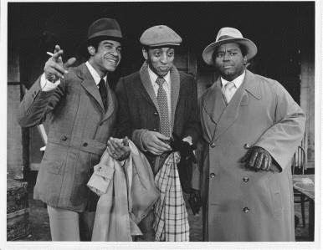
“The Last Minstrel Show .” Photo credit Tucker.
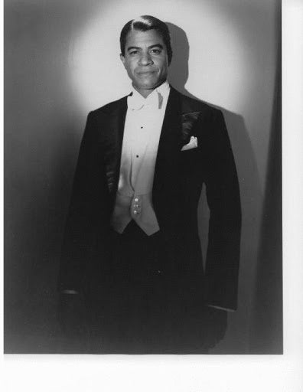
Tucker in The Cotton Club as “Kid Griffin .” Photo credit Tucker.
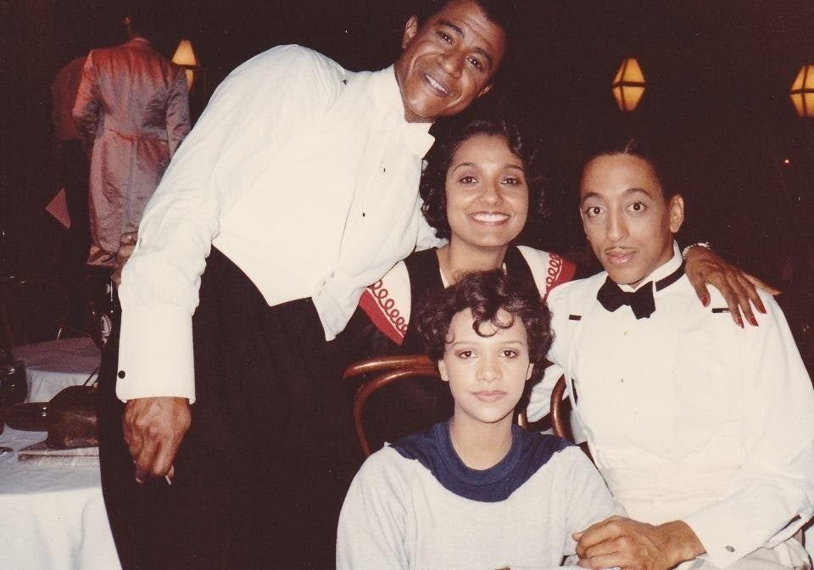
On set of The Cotton Club with Greg, Tucker and friends. Photo credit Tucker.
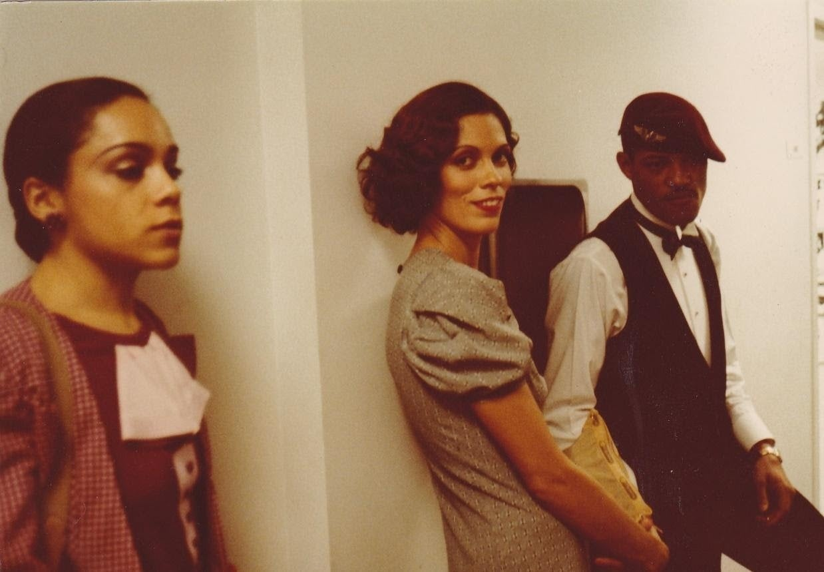
Behind the scenes on The Cotton Club. Photo credit Tucker
Tucker’s great essay on his time with commercial for USAA, aptly titled “USAA ,”
“Long ago and far away (70’s, NYC) I was fortunate enough to shoot more than 100 commercials. Those and V/O are a real boost to a young actors bottom line. And then, somehow, I was just no longer “that guy .” Some of those campaigns wandered into the low 5 figures; it was all found money and was padding my pension.
Skip ahead 40 years. Haven’t even had a commercial agent in fifteen years. I hear buzz about a USAA campaign. I’ve been their client since 1968 as a young Lt. I doubted they’d ever cast me, tho My face is too well known. So I kept passing. They called again, said “bring some old photos from the war.” This meet was close by in Sherman Oaks and I had the time, so I stopped by.
The session was run by Dan Bell. Small world. Back in the late 70’s I was visiting patients in NY VA Hospitals with the Veterans Bedside Network. I decided to produce a two character play I’d found about two vets in a foxhole in Vietnam: one black, one white. Very funny, very dark. I got a grant and reached out to Dan, now back in LA. We’d met on an earlier theater piece in NY and I knew he’d be surfer dude perfect. I created a mobile set, sandbags, sound effects, uniforms. Dan flew in and we had a ball performing this dark little one act at the five NY area hospitals. Still have it on tape.
So, we meet, catch up, Dan puts me on tape. I go home and forget about it. A week later, there’s a call. They want to BOOK me. This turns into a whole campaign of multiple spots, lifts, print work….Long story short, that one visit led to a healthy SIX figure payout. You just never know. Btw, all this took place 8 years ago.”
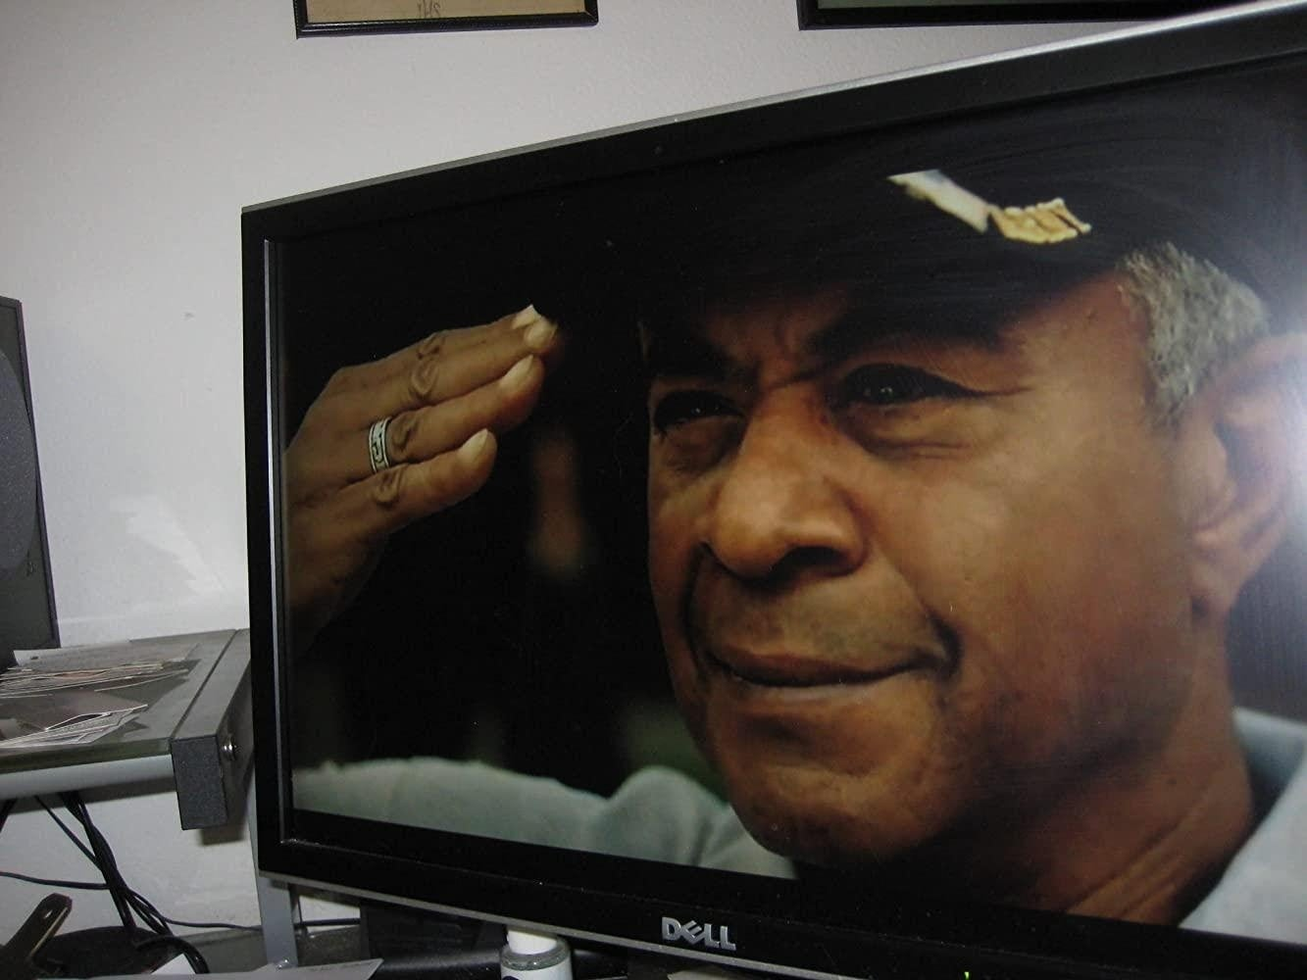
Tucker appearing in the USAA commercial. Photo credit IMDB.com.
7. What was your experience in working with Francis Ford Coppola and Robert Zemeckis?
I very much enjoyed working with Bob. I was told that I was the first person he ever cast from a video as we had not met in person yet. I had only sent in an audition on tape. Later, Bob and Steve Starkey, producer on the film pulled me aside at the premiere and told me that they had wanted to honor the work that I did for the film, so they made me a lead in it. It was my first big time lead. It was a movie that my parents saw and could share with their friends. It was kind and special for him Bob to do that for me. Other favorites include Francis of course and Alan Pakula.
I worked on Presumed Innocent with Alan Pakula. I enjoyed spending time and working with Harrison Ford and Raul Julia. My testimony scene with Raul Julia had to be cut to make time for the two hour edit. It was some of the best work I have done, and it tore my heart out having it cut. Raul was just wonderful to act with.
It was wonderful working Jodie Foster in Contact. I admire her so much. Jerry Griffin was great to spend time with since he’d been the mission commander at NASA during the moon missions.
I love the Cotton Club: Encore cut and am grateful for Francis releasing that where so many performers got their life back on screen, where some of them are no longer with us. So many of them are gone. Some of them had done so much and were not in the theatrical release of the film, but now they are back. I am so happy for their families and those that are still alive to see themselves on screen in the film. I love the reality he gave me back. I got my screen life back to where my role in the film was to keep things cool at the Cotton Club.
We had initially improved the film on a green screen where Francis had all of these state-of-the-art things such as cameras and effects. Bob Hoskins and Fred Gwynne did an improv in front of the green screen where you would have paid to watch that improv. The scene is in the movie based on their improv. I saw it and the work was just so delicate and fine. Fred and I used to race everyday while in makeup in doing crossword puzzle for the NY Times. Working with Fred Gwynne on the film was great. He was a very intelligent man; had attended Harvard!
The mob was very, very present on the film. We had been shooting the movie for about five or six weeks and the mob was messing with Francis, so he just left and went to England. The mob was trying to withhold money or something. They resolved their differences and Francis then came back from England to resume filming. I remember another instance where Francis was on set embracing two smaller men. Francis is a bear of a man. The two men he was embracing were Steven Spielberg and George Lucas. He was their mentor. It was a scene I will never forget.
For all those years I knew the footage existed that became the encore version of the film. I thought the mob had the footage. Francis was a hired gun on this film. The encore version absolutely flows. I have pictures of being on set where Greg’s daughter Daria and Francis daughter Sophia are running around the set as kids. Tom Waits was my roommate for five months on the shooting of the film. Tom is a trip. On set we were all doing improv’s, even with Nic Cage that got intense. Some people on set were startled by how profane our improvs got.
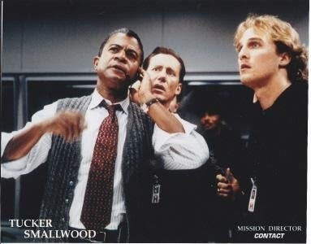
Tucker in Contact with James Woods and Matthew McConaughey. Photo credit Tucker.
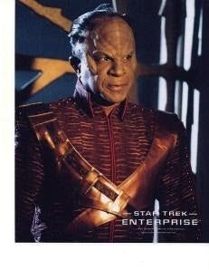
Tucker in “Star Trek: Enterprise .” Photo credit Tucker.
Tucker’s essay on his work in Contact, “Contact: Dispatches from the Front ,”
“As usual, I am the bell cow…the point man…as usual, I am doing more work than most and receiving less for it than many. As usual, I am doing it, simply because I love the work…and it’s a good thing, for there is much of it to do. I have perhaps 90% of all the live dialogue…and this is my fourth day of twelve and more hour days…and tomorrow and the following tomorrow’s promise nothing different….no polite chat, this…it is an intense, ‘Mission Impossible’ sequence.
I am the Mission Director. I command…amidst the sea of principals, atmosphere, Jodie Foster video playback and crew. This is no knock on her, she’s generous and hardworking and this is her 64th day…and my 4th. The intricate set of a launch command aboard ship is three-tiered, with perhaps fifteen video monitors and dozens of computer screens everywhere, depicting data, Jodie (Ellie) in the POD (pre-recorded) and ‘live’ cutaway shots of the MACHINE, with blue screen in the background….To ‘dance’ to a pre-recorded master and fit your action between her running cues is a daunting task…add to the degree of difficulty, NEW lines written for us AFTER her master was shot, scripts that do not remotely accurately reflect what she is saying at any given time, and a severely challenged video crew, manfully trying to cue up and playback three separate signals while a camera dollies, pans, zooms, tilts and whips amongst the multiple players, many themselves in motion and you have an inkling, but only an inkling of what I’ve been handling since last Wednesday…
Ain’t complaining, happy to be on board…proud of my ability to ‘block’ as well as ‘go long’ …and I am grateful finally to be receiving words of appreciation from my director for my focus and professionalism. I got it from the first day from the crew and cast…but had begun to feel like ‘the mule’, who is hitched up and expected to pull till he is released at dusk – and I will, just because I do it for my OWN sense of professionalism. But like anyone, I appreciate a pat at the end of the day…and hadn’t received it from he who should have most valued my contribution…
Perhaps because on the first night of shooting, after 8 hours of shooting scenes which involved a NOD FROM ME (and I did it, over and over, never big, never too small, always in the scene), we entered the master set to ‘rehearse and read thru’ the entire launch sequence….and James Woods arrived…I love Jimmy’s work, he’s easily one of my favorite actors, focused, intense, witty…and ON. Since he had NO lines in the work that would require his presence for the next week, he proceeded to take over the rehearsal, arranging business, focus and directions that had little to do with what was to be shot and was in fact undercutting and distorting the reality of my character. After about twenty minutes of this, something happened. Amidst perhaps 60 extras, as many crew and the entire cast of principles present, I stepped forward and WENT OFF…
Without particular anger or personal animus, but in my inimitable way, I told them who the Mission Director was (God) to whom he answered (no one) and that while he might be fired or relieved of duty, as long as I was that Director, I would decide when and if the mission were to be aborted or launched. That’s why I was hired for the launch, that’s my JOB, outranked undoubtedly by many present, but as far as this launch was concerned, I make the decisions…
This took about five minutes, perhaps…there was a silence, perhaps 30 seconds…and then Bob stepped in and redirected our efforts, rather along the lines I’d suggested, James continuing to contribute but acknowledging my point of view…and we went home. That night, I reflected upon the possible folly of my ‘forwardness’ – ‘what had I done!!?’ ‘I’ll never eat lunch in this town again’…but knew I could have done nothing else. Personally, I’d defer in a heartbeat to these major players, but I am absolutely fearless in defense of my character. The next day, and even leaving that night, people came up to me discreetly – crew, cast, to express admiration for my ‘speech’…but more importantly, I learned from key crew, that’s what Jimmy DOES…”He sucks the air out of any room he’s in….(the casting director came up to me at lunch and playfully noted she had “heard about the ‘to-do’ Jimmy and I’d had the night before…and Bob probably admires you for standing up to him.”
Maybe so….but Bob also may have made a mental note that he had a potential ‘loose cannon’ on his hands….which didn’t make my frequent requests for MY NEEDS in handling the demanding pre-recorded track any more welcome or easier…but he seems to have come to realize that I am exclusively focused on ‘the work’ and only want to make it the best it can be in the way he wants it to be….and each day its’ getting better, for he sees my ideas are good and knows I’m thinking right along with him…and it’s becoming fun…but it’s still very hard work…
CONTACT II
Today, February 14, I wrapped my work on the film CONTACT…I experienced such an outpouring of love and affection during my work and particularly as I left, it seems somehow appropriate that it was Valentine’s Day. Earlier in the day, the producer, Steve Starkey had an embossed denim shirt with the film’s logo embroidered on it, left in my trailer. When I thanked him for the cherished memento, he said, “We thank you… for just being Tucker”
My character, the Mission and Test Director, was such a lovely marriage of their vision for the film’s leader of the launch sequences and my own sensibilities as prior military, forceful, articulate, authoritative and comfortable in the driver’s seat. I had been cast, solely from my audition on tape, purportedly the first actor ever so cast by Bob Zemekis, who normally insists upon meeting with each of his actors in person. The technical demands of working in both sequences with a pre-recorded video track were daunting, but I relished the challenge. And because I needed no attention to the persona of the character (he WAS me), I could devote all my energies(and a good thing!) to being in sync with what had already been established and had to be served (first, Jody Foster’s ELLIE on tape, later Tom Skerritt’s DRUMLIN and others, also pre-taped)…
The days were long and exhausting and that fatigue fed into the next, but tired as I was each morning as I arose, I knew that the core crew and cast had been at this since SEPTEMBER!…and that alone demanded MY energy to keep THEIRS up. If there was a difficulty for me, it was that my character was CERTAIN, never tentative, always definite….I could never allow myself the luxury to ‘feel’ my way… and since he was constantly being re- written, it required all of my gifts to keep him ‘on top of everything’, even as the fatigue, the re-writes, the technical video demands continually upped the ante and challenge. I accepted and met the challenge…and was rewarded with their respect. When it was announced this evening that I had completed my work, the entire room, a huge one, filled with people, cast, crew, more than 70, many of whom I had come to know and care for, rose as one and applauded, for an embarrassingly long time. When I quieted them for an instant and told them, “It is always an honor to serve with an elite unit…I salute all of you.” And meant every word; working with such a group of professionals spoils an actor for what lies ahead with lesser cohorts. I left, accepting the thanks, handshakes and hugs from my director Bob, my producer Steve, my ever-so- respected STAR, Jody who surprised and filled my heart with pride when she rose to take me in her arms…the 1st AD, Bruce, Bobby, my camera man, and just ALL of them….
This was their 89th day of shooting (and that doesn’t include weekends and days off). It was Valentine’s Day, it was 9PM and we started at 7:30 AM, they wanted to go have a drink and celebrate with their loved one, but more work remained to be done. Yet they took a moment to let me know that my contribution had been valued and appreciated…and I will hold onto that memory for many a day, for it came from people who work with the best in our field, every day of their professional lives. I know how special each one is in this business…and they told me I am a peer…and that’s all I ever wanted, all I ever aspired to, as an actor. My heart is very full.
Yesterday, I had given a copy of my CD, INCARNATION, to the father and son who ran our craft services. A very gracious and accomplished Black man, John played music of all sorts, all tasteful, in his trailer…and I hoped to repay his kindness of cappuccinos by sharing some of my music…he played it, through the day, yesterday, as cast and crew stopped by for a snack or special coffee…and people continuously came up to me and expressed interest in the music, ‘how could they buy it?’, was that really me singing?…my audio man, Earl, expressed a desire to have a copy (and I’d had a ‘feeling’ I’d wanted to give him one, somehow I KNEW he loved blues). So today, I brought him one, too. And HE played it, quietly, just off the sound stage…and people continued to ask about the music and express their affection and admiration for the songs…so I let those who were computer-literate know that they could put my name into their search- engines and find my homepage and instruction for buying the CD…and last night printed out the mailing addy for those who don’t play on the internet…..but it was fun to share the music with so many…and perhaps that contributed to the universal embrace I experienced from them all…an actor, and professional, yes…but someone with a few more facets than might have first been seen….
We’ll see how many cards Clark receives in the weeks to come, requesting a copy of the music.”
8. What leadership lessons in life and from the Army have helped you most in your career?
You have to show up. You have to know your profession and be willing to do the work. The joy in each comes not from attention or honors but from fulfilling personal values of that which constitutes excellence.
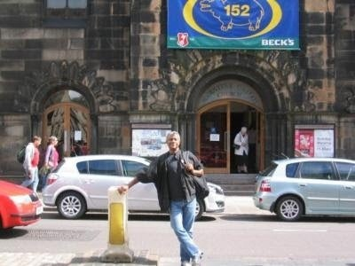
Tucker in Edinburgh, UK. Photo credit Tucker.
9. As a service, how do we get more veteran stories told in the Hollywood arena?
Find and write good stories. There is surely no shortage.
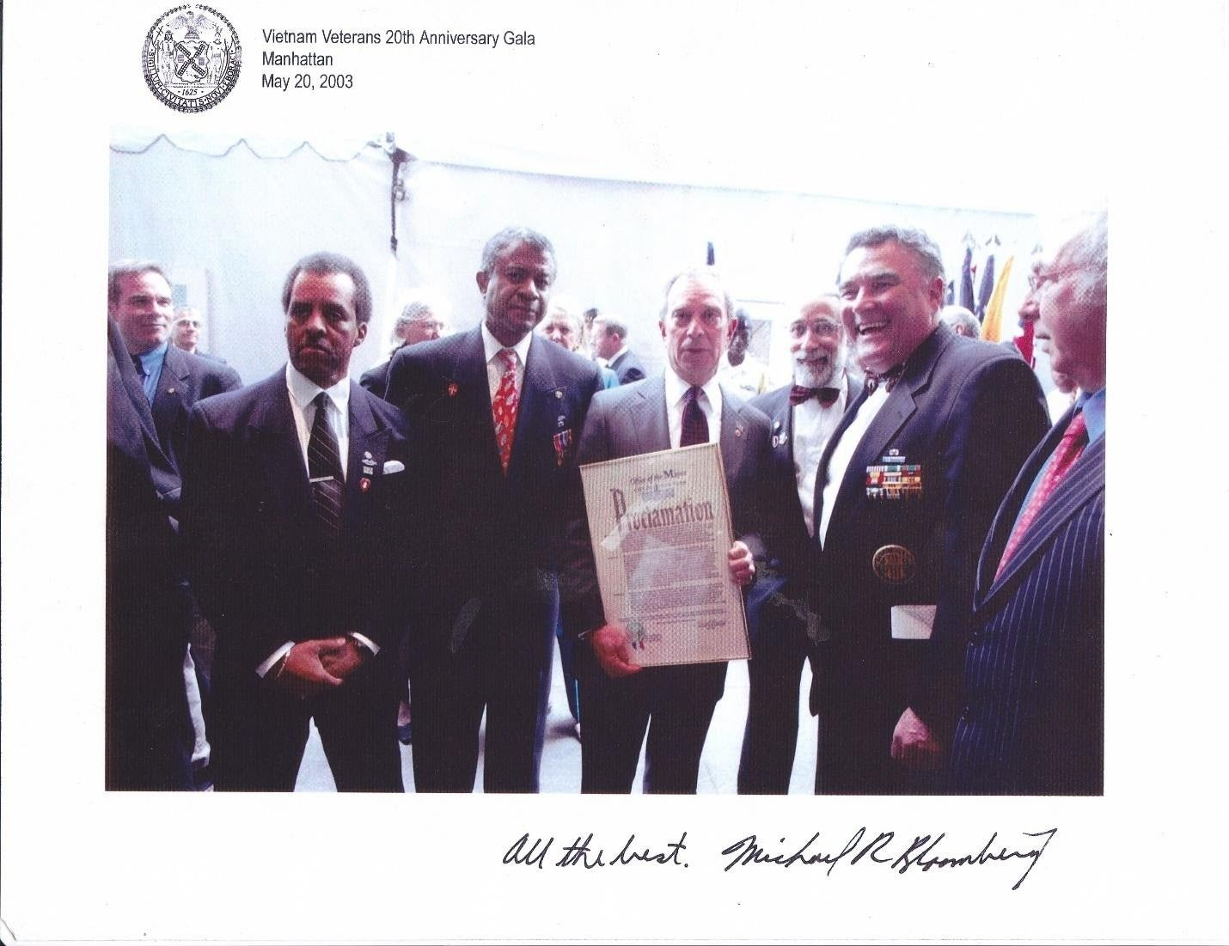
Tucker with Mayor Bloomberg. Photo credit Tucker.
10. What are you most proud of in life and your career?
Surviving critical injuries to learn a new profession. Then succeeding in every aspect in which I was allowed to compete. Soaps, commercials, voice-overs, theater, film, comedy, drama, public affairs, children’s TV.
I do have great concern for our military members and veterans currently serving. I feel some service members need to stand up for what is right and look at what orders are being given and by who. Some Generals need to do the right thing as well and stand up
We need to have good leadership to help us fight global warming and support the environment.
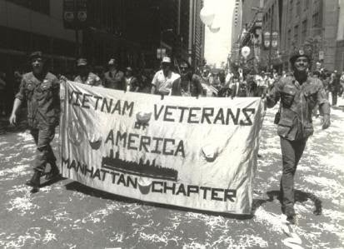
Tucker marching in a later “Welcome Home” parade for Vietnam veterans in NYC where he is a member of the chapter. Photo credit Tucker.
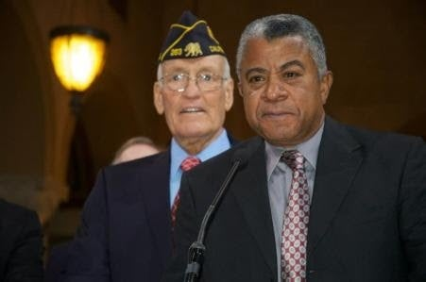
Tucker speaking on behalf of veterans. Photo credit Tucker.
Tucker’s essay “Mahalia”
MAHALIA
For whatever reasons, on this Christmas Day I’m remembering an Easter Sunday years ago. I recently heard a spiritual, “Precious Lord, Take My Hand” and flashed back to the late ’70s, when I was performing in MAHALIA, a musical play based on her life. In the first act, I was a member of the choir and other supporting characters; in the second act, I was Minnis, her third husband. Minnis was a jazz pianist, a charmer and a philanderer.
When preparing the character, I struggled to find that emotional connection between him and Mahalia. She was obviously wealthy and renowned, but hardly an object of physical desire.
I thought back to a preview performance I’d seen years before, of a musical called SOON. The cast included Barry Bostwick, Peter Allen and Richard Gere. During that performance, an actress appeared on stage and ascended a staircase to a single spot-lit balcony. She was rather short, rather stout and not particularly attractive. Then she began to sing. And in that moment, she became the most beautiful, the most desirable, the most compelling woman in the universe. In a theater seating hundreds, she sang to me. Each member of the audience had that same experience; her voice, her music, her message was received individually. Her name was Nell Carter.
That memory explained why Minnis loved Mahalia, loved her on every level. Her art, her majestic gift transcended mere physical attractiveness and made her all things desirable. And during the run of this musical (written by John Lewis of the Modern Jazz Quartet) each night my character Minnis fell in love with Mahalia, who was performed by the incomparable Esther Marrow, herself a Mahalia protégé.
I was then living in NYC and our performances were in Stamford, Connecticut, which meant a daily drive or train ride to the theater. I’d arranged the rental of a station wagon and a number of the cast shared that drive each day. It was a time of fellowship, jokes, bickering; the animated energy generated by a theatrical troupe.
Today was Easter Sunday. I then lived on Central Park West and I had my pre-show rituals. My day would begin with a walk along the park to buy the Sunday Times, while reflecting upon last night’s performance and my intentions for today’s matinee and evening show. The morning was warm and sunny, the work was going well, and I was looking forward to really nailing my featured love song to Mahalia today.
There’d been some drama in the past regarding my inclination to venture from the notes written and to improvise. I’m not a Broadway baritone, not even really a singer in the true sense of the word. (You’d be surprised how being shot through the throat affects your voice.) But I am musical and a fairly interesting actor. So each show, I walked that fine line of fulfilling the intentions of the composer and fulfilling my own need to express the truth of my character. I’d tell them, “Well, Esther improvises…” And they’d then tell me, “Well, yeah…but she’s ESTHER MARROW!”
As I approached the newsstand on the corner of CPW and 100th St, I noticed two young men exiting the park and running across the street toward me. One wore a red windbreaker. They seemed Hispanic – or is Latino more correct these days? As they reached my side of the street and stopped ten feet away, one cried out to me, “You killed him. You killed him.” The other drew a revolver from his waist, cocked it and aimed it at my chest.
Time stopped, as it does in such moments. One takes in everything. Everything. The smells, the light, the sounds are all super-heightened, the ultimate Kodachrome. I wondered, in abstract, whimsical dispassion, “Does he mean Jesus? It is Easter Sunday…” And then he pulled the trigger.
Imagine standing inside a wind tunnel, yet within the eye of a hurricane. Everything about us roared and swirled, but this microcosm was absolute stillness and silence. There was a click. The sound of a hammer striking…what? A faulty cartridge? A damaged firing pin? An empty chamber? Only God knows and He ain’t talkin’. His friend said, “Man, man, man – you f*****’ up!” In those instances, I’d taken perhaps one step towards them, perhaps two…and have no idea what I intended.
They proceeded to wheel about, race back across CPW and disappear into the park. I stood there for some moments. There was no one around. No one. I collected myself, entered the corner newsstand, bought my Sunday New York Times and walked back to my home. There, I called the police and told them what had happened. They eventually came by; I gave a report and they left to search for the pair. They told me, “You were menaced.” Curious, the subtle difference between menaced and murdered…just an unreliable weapon.
In subsequent years, when I recounted this experience, friends (knowing something of my temperament and history) asked, “So, what’d you do then? Did you take his gun and pistol-whip him and beat the snot out of them?” I’d tell them that life is seldom like a movie. That I simply stood there, remembering close calls in Vietnam, grateful that this encounter had ended so well.
After an hour or so I picked up the rental car, met my cast members and began the drive to Stamford. I don’t remember discussing the morning’s events – not sure why.
During Act One, as we began to sing, “Precious Lord, Take My Hand,” I suddenly broke down in tears – just lost it, right there on stage in front of everyone. I was led backstage by someone; and there sobbed and sobbed, inconsolably. There was a discussion…could I continue, could I regroup?
They covered for me til the end of the first act and during the intermission, I got my own act together. Act Two proceeded without incident…and I seem to recall I sang my solo rather well that day.
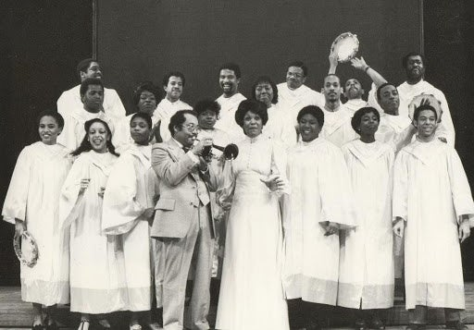
Cast notables include Esther Marrow, Nat Adderly, Jenifer Lewis and Keith David. 25

Top of Form
Bottom of Form
Top of Form
Bottom of Form

